CSE 219 — Signals and Linear Systems
Lec 3–4 · Fast Fourier Transform: Radix-2, Matrix FFT, Fast Convolution, Bluestein
Lesson notes · Exam approach · TF practice with solutions · Quick notes (Ashraf Sir's portion)

How to Read These Notes
EXAM FOCUS | Exam importance, where it appears in the TF collection
MEMORIZE | Rules, tables and formulas to memorize
TRAP | Common mistakes and exam traps
EXAM-READY ANSWER | Model wording you can write in the exam
NOTE | Extra explanation / clarification
Grey box, monospace | Code, worked tables, derivations and hand-drawn sketches
Centered grey box | Formula to remember / final numerical result
Purple heading / ✔ green | Practice questions / their solutions

Contents
Exam Map — What the TF Papers Ask — FFT questions and their weight
Lesson 5 — Radix-2 Decimation-in-Time FFT — derivation, butterflies, bit reversal, complexity, a full 8-point example
Lesson 6 — Radix-2 Decimation-in-Frequency FFT — first/second-half split, DIF butterfly, bit-reversed outputs
Lesson 7 — The Matrix (Cooley–Tukey / Bailey) Formulation — column-major input, row DFTs, twiddles, column DFTs
Lesson 8 — Fast Convolution and Bluestein's FFT for Prime N — O(N log N) filtering; chirp-z identity; M ≥ 2N − 1
Quick Notes — FFT — merged revision notes + key diagrams
NOTE Slide numbers are PDF page numbers of Lecture 3 - Fast Fourier Transform.pdf (19 pages, “Lec 3”) and Lecture 4 - Advanced FFT.pdf (24 pages, “Lec 4”); the printed slide number is one less.

Exam Map — What the TF Papers Ask
Session (paper) | Questions answered by this note
2023-24 (CSE 219) | Q5(a) 8-point DFT of {1,2,3,4,3,2} by radix-2 DIT FFT with all butterflies (15) · Q7(a) 2×4 Cooley–Tukey (matrix) DFT of {1,2,3,4,9,0,7,8}, steps i–iii (15) · Q7(b) Chirp-z (Bluestein) derivation; why padding M ≥ 2N−1 (10)
2022-23 (CSE 219) | Q4(c) Compare computational complexity of direct DFT and radix-2 FFT (15)
2017-18 (CSE 311) | Q3(b) DIF FFT formulation; 8-point signal-flow graph; bit-reversed outputs (24)
2014-15 (CSE 311) | Q7(c) Recurrence relationship of the FFT (15)

EXAM FOCUS CSE 219 2023-24 spent 40 marks here: an 8-point radix-2 DIT FFT with every butterfly (Q5(a), 15), a 2 × 4 matrix FFT (Q7(a), 15) and the Bluestein derivation (Q7(b), 10); 2022-23 asked the DFT vs FFT complexity (Q4(c), 15). Practise the 8-point DIT until you can do it in 12 minutes, and know W₈ by heart.

Lesson 5 — Radix-2 Decimation-in-Time FFT
Lec 3 sl. 4–15, 19

1. Why: the Naive DFT Is O(N²) (sl. 4)
Each of the N outputs needs N complex multiplications and N − 1 additions: N² multiplications in all. One second of audio (N = 44 100) needs ≈ 2 × 10⁹ operations.

2. The Even/Odd Split (sl. 7–9)
X[k] = Σ_{r} x[2r]W_N^{2rk} + Σ_{r} x[2r+1]W_N^{(2r+1)k}, W_N^{2rk} = W_{N/2}^{rk}
= G[k] + W_N^k H[k] G = N/2-point DFT of the evens, H = N/2-point DFT of the odds
G[k + N/2] = G[k], H[k + N/2] = H[k] (period N/2), and W_N^{k+N/2} = −W_N^k, so for 0 ≤ k < N/2:

X[k] = G[k] + W_N^k H[k] X[k + N/2] = G[k] − W_N^k H[k]
Recurrence (the “recurrence relationship of the FFT”): an N-point DFT = two N/2-point DFTs + N/2 butterflies. Repeat until 2-point DFTs (X[0] = x[0] + x[1], X[1] = x[0] − x[1]).
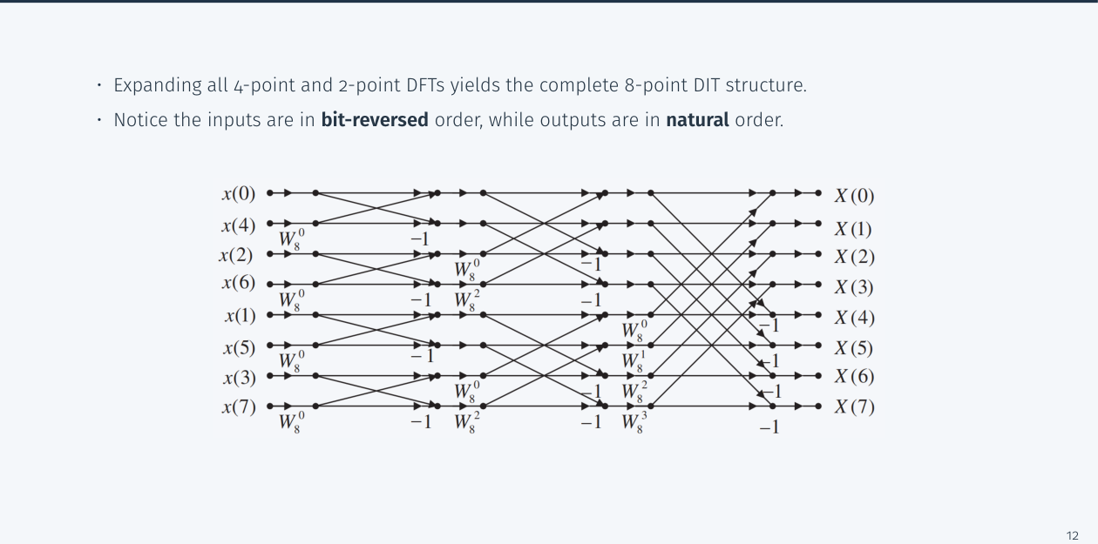
Figure 5.1 — Full 8-point DIT flow graph: bit-reversed inputs, natural-order outputs (Lec 3, sl. 13)

3. Bit-Reversed Input Order (sl. 14)
n: 0 1 2 3 4 5 6 7
binary 000 001 010 011 100 101 110 111 → reversed 000 100 010 110 001 101 011 111
order: x[0] x[4] x[2] x[6] x[1] x[5] x[3] x[7] (evens before odds, then even-evens before odd-evens, …)

4. Complexity (sl. 15)
 | Direct DFT | Radix-2 FFT
complex multiplications | N² | (N/2)log₂N (one per butterfly)
complex additions | N(N − 1) | N log₂N
stages / butterflies per stage | — | log₂N stages, N/2 butterflies each
N = 8 | 64 | 12 (5.3× fewer)
N = 1024 | 1 048 576 | 5 120 (≈ 205×)
N = 2²⁰ | 1.1 × 10¹² | 1.05 × 10⁷ (≈ 10⁵×)

Plus O(N) for the bit-reversal permutation. Requires N = 2^m; otherwise zero-pad to the next power of 2 (fine for spectra — it only interpolates the DTFT — but it changes the period of a periodic signal) (sl. 19).
MEMORIZE W₈⁰ = 1, W₈¹ = (1 − j)/√2 = 0.7071 − 0.7071j, W₈² = −j, W₈³ = −(1 + j)/√2 = −0.7071 − 0.7071j; W₄¹ = −j. A butterfly: top = g + W·h, bottom = g − W·h.

Exam Approach
1. Zero-pad to a power of 2; write the bit-reversed input order.
2. Stage 1: 2-point butterflies (W = 1) on adjacent pairs.
3. Stage 2: 4-point combines with W₄⁰ = 1, W₄¹ = −j (pairs 2 apart).
4. Stage 3: 8-point combines with W₈⁰…W₈³ (pairs 4 apart). Show every intermediate value.
5. Check: X[0] = Σx, X[4] = Σ(−1)ⁿx[n], X[8 − k] = X*[k] for real x.

Practice — Lesson 5
(a) Actual — CSE 219 2023-24 Q5(a). (b) Actual — CSE 219 2022-23 Q4(c). (c) Actual — CSE 311 2014-15 Q7(c). (d) Practice set 1.2.
(a) x[n] = {1, 2, 3, 4, 3, 2}. Compute the 8-point DFT with the radix-2 DIT FFT, showing all intermediate stages with a proper butterfly diagram. (15)
(b) Compare the computational complexities of the DFT and the radix-2 FFT. (15)
(c) Derive the recurrence relationship of the FFT. (15)
(d) 4-point DIT FFT of {2, 1, −3, 4}.

✔ Solution
(a) Pad: x = {1, 2, 3, 4, 3, 2, 0, 0}. Bit-reversed order: x0 x4 x2 x6 x1 x5 x3 x7 = 1, 3, 3, 0, 2, 2, 4, 0

Stage 1 (2-point, W = 1):
(x0,x4) = (1,3) → 1+3 = 4, 1−3 = −2
(x2,x6) = (3,0) → 3, 3
(x1,x5) = (2,2) → 4, 0
(x3,x7) = (4,0) → 4, 4
Stage 2 (4-point, W₄⁰ = 1, W₄¹ = −j):
evens G: (4, −2 | 3, 3): G0 = 4+3 = 7, G1 = −2 + (−j)3 = −2−3j, G2 = 4−3 = 1, G3 = −2 − (−j)3 = −2+3j
odds H: (4, 0 | 4, 4): H0 = 4+4 = 8, H1 = 0 + (−j)4 = −4j, H2 = 4−4 = 0, H3 = 0 − (−j)4 = 4j
Stage 3 (8-point, X[k] = G[k] + W₈^k H[k], X[k+4] = G[k] − W₈^k H[k]):
k=0: W·H = 8 X[0] = 7+8 = 15 X[4] = 7−8 = −1
k=1: W₈¹·(−4j) = (0.707−0.707j)(−4j) = −2.828−2.828j
X[1] = −4.828−5.828j X[5] = 0.828−0.172j
k=2: W₈²·0 = 0 X[2] = 1 X[6] = 1
k=3: W₈³·(4j) = (−0.707−0.707j)(4j) = 2.828−2.828j
X[3] = 0.828+0.172j X[7] = −4.828+5.828j

X = {15, −4.828−5.828j, 1, 0.828+0.172j, −1, 0.828−0.172j, 1, −4.828+5.828j}
Checks: X[0] = Σx = 15 ✓; X[4] = 1−2+3−4+3−2 = −1 ✓; X[7] = X*[1], X[5] = X*[3] ✓ (numpy agrees)

(b) Direct DFT: N² complex multiplications and N(N − 1) complex additions (each of N outputs sums N products). Radix-2 FFT: log₂N stages × N/2 butterflies, each with one complex multiplication and two additions ⇒ (N/2)log₂N multiplications and N log₂N additions (+ O(N) bit reversal); trivial twiddles (±1, ±j) reduce it further. Speed-up N²/((N/2)log₂N) = 2N/log₂N: 5.3 for N = 8, ≈ 205 for N = 1024, ≈ 10⁵ for N = 2²⁰ — a day of computation becomes seconds. Limitation: N must be a power of 2 (zero-pad, or use mixed-radix/Bluestein).
(c) The split in §2: X_N[k] = G_{N/2}[k] + W_N^k H_{N/2}[k], X_N[k + N/2] = G_{N/2}[k] − W_N^k H_{N/2}[k], applied recursively to G and H. Cost recurrence: C(N) = 2C(N/2) + N/2 multiplications, C(2) = 0 (W = 1) ⇒ C(N) = (N/2)log₂N.
(d) order x0 x2 x1 x3 = 2, −3, 1, 4; stage 1: (2−3, 2+3) = (−1, 5); (1+4, 1−4) = (5, −3)
stage 2: X0 = −1 + 5 = 4; X1 = 5 + (−j)(−3) = 5+3j; X2 = −1 − 5 = −6; X3 = 5 − (−j)(−3) = 5−3j

Lesson 6 — Radix-2 Decimation-in-Frequency FFT
Lec 3 sl. 16–18
Split the time sum into first and second halves:
X[k] = Σ_{n=0}^{N/2−1} [x[n] + (−1)^k x[n + N/2]] W_N^{kn} (W_N^{kN/2} = (−1)^k)
even k = 2m: X[2m] = Σ (x[n] + x[n+N/2]) W_{N/2}^{mn} = DFT_{N/2}{a(n)}
odd k = 2m+1: X[2m+1] = Σ [(x[n] − x[n+N/2])W_N^n] W_{N/2}^{mn} = DFT_{N/2}{b(n)}
a(n) = x[n] + x[n + N/2], b(n) = (x[n] − x[n + N/2])·W_N^n (add/subtract first, THEN twiddle)

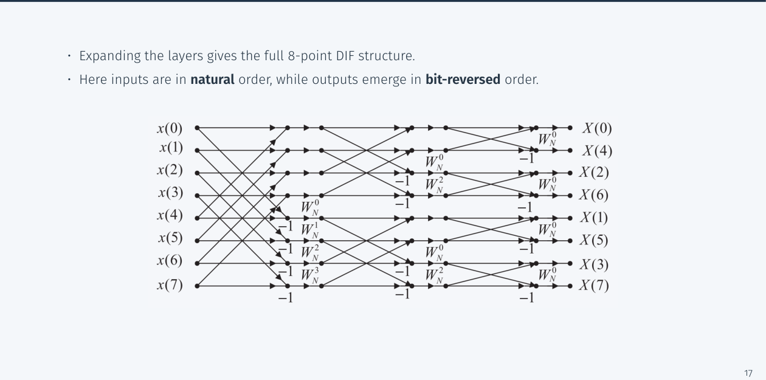
Figure 6.1 — 8-point DIF flow graph: natural-order inputs, bit-reversed outputs (Lec 3, sl. 18)
 | DIT | DIF
split | time index even/odd | time first half/second half (= output even/odd)
butterfly | multiply by W, then add/subtract | add/subtract, then multiply by W
input order | bit-reversed | natural
output order | natural | bit-reversed
cost | (N/2)log₂N mult. | (N/2)log₂N mult.

Practice — Lesson 6
(a) Actual — CSE 311 2017-18 Q3(b). (b) Constructed.
(a) Formulate the decimation-in-frequency FFT; draw the 8-point signal-flow graph and explain why the outputs come out in bit-reversed order. (24)
(b) Run the first DIF stage on x = {1, 2, 3, 4, 3, 2, 0, 0}.

✔ Solution
(a) Derivation as in the grey box; apply it again to a(n) and b(n) (N/4-point blocks), then to 2-point butterflies. The 8-point graph (Figure 6.1): stage 1 pairs (n, n + 4) with twiddles W₈⁰…W₈³ on the difference branch; stage 2 pairs (n, n + 2) inside each half with W₄⁰, W₄¹; stage 3 pairs (n, n + 1) with W = 1. Output order: stage 1 separates even k (top) from odd k (bottom), stage 2 separates k mod 4, …, so the final position of X[k] is k with its bits reversed: X[0], X[4], X[2], X[6], X[1], X[5], X[3], X[7].
(b) a(n) = x[n] + x[n+4] = {1+3, 2+2, 3+0, 4+0} = {4, 4, 3, 4} → its 4-point DFT gives X[0], X[2], X[4], X[6]
b(n) = (x[n] − x[n+4])W₈ⁿ = {−2·1, 0·W₈, 3·(−j), 4·W₈³} = {−2, 0, −3j, −2.828−2.828j} → X[1], X[3], X[5], X[7]
check: DFT₄{4,4,3,4} = {15, 1, −1, 1} = X[0], X[2], X[4], X[6] ✓ (Lesson 5)

Lesson 7 — The Matrix (Cooley–Tukey / Bailey) Formulation
Lec 4 sl. 5–14
Radix-2 as a table (sl. 6–8): put x into a 2 × N/2 matrix column-major (n = 2n₂ + n₁: row 0 = evens, row 1 = odds); DFT each row (→ G, H); multiply row n₁ by W_N^{n₁k₂}; 2-point DFT down each column (the butterflies); read the result row-major (k = (N/2)k₁ + k₂).
General N = N₁N₂ (sl. 11–13): n = N₁n₂ + n₁ (column-major), k = N₂k₁ + k₂ (row-major)
(N₁n₂ + n₁)(N₂k₁ + k₂) = Nn₂k₁ + N₁n₂k₂ + N₂n₁k₁ + n₁k₂; W_N^{Nn₂k₁} = 1
X[N₂k₁ + k₂] = Σ_{n₁} W_N^{n₁k₂} [Σ_{n₂} x[N₁n₂ + n₁]W_{N₂}^{n₂k₂}] W_{N₁}^{n₁k₁}
twiddle └ N₂-point DFT of row n₁ ┘ N₁-point DFT down columns

Bailey's four-step FFT (sl. 14): (1) arrange N₁ × N₂ column-major; (2) N₂-point DFT of each row; (3) multiply entry (n₁, k₂) by W_N^{n₁k₂}; (4) N₁-point DFT of each column; read row-major. Recursing on the factors gives O(N log N) for any N with small prime factors (radix-3: N₁ = 3, sl. 9–10).
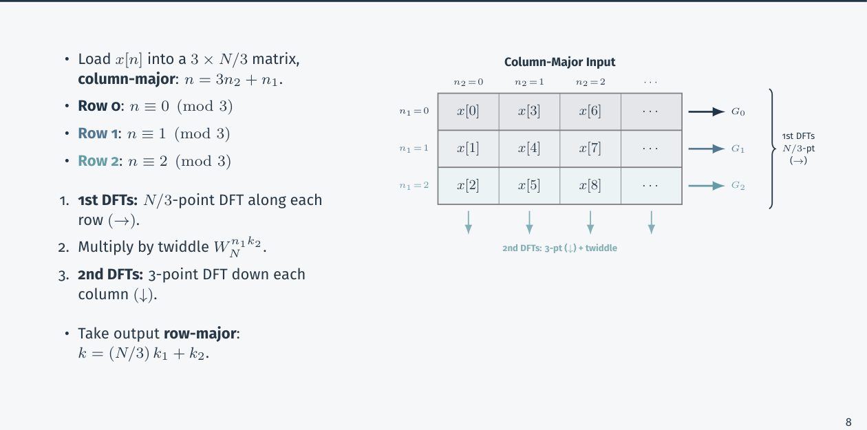
Figure 7.1 — Radix-3 as a 3 × N/3 table (Lec 4, sl. 10)

Practice — Lesson 7
(a) Actual — CSE 219 2023-24 Q7(a). (b) Practice set 2.2.
(a) Using the radix-2 Cooley–Tukey 2D matrix formulation, compute the DFT of x = {1, 2, 3, 4, 9, 0, 7, 8}: (i) arrange in the 2 × 4 column-major matrix (evens/odds) and compute the 4-point DFT of each row (matrix G); (ii) twiddles W₈^{n₁k₂} in a + jb form; H = G ∘ W; (iii) 2-point DFTs down each column, read row-major. (15)
(b) Same method for x = {1, 3, −1, 2, 0, 4, 2, 1}.

✔ Solution
(i) Row 0 (n₁ = 0, evens): x0 x2 x4 x6 = 1, 3, 9, 7 Row 1 (odds): x1 x3 x5 x7 = 2, 4, 0, 8
4-point DFT (W₄ = −j): [a,b,c,d] → [a+b+c+d, (a−c) − j(b−d), a−b+c−d, (a−c) + j(b−d)]
G row 0: [20, −8+4j, 0, −8−4j] G row 1: [14, 2+4j, −10, 2−4j]
(ii) Twiddles W₈^{n₁k₂}: row 0: 1, 1, 1, 1; row 1: 1, 0.7071−0.7071j, −j, −0.7071−0.7071j
H row 0: [20, −8+4j, 0, −8−4j]
H row 1: [14, (2+4j)(0.7071−0.7071j) = 4.2426+1.4142j, (−10)(−j) = 10j, (2−4j)(−0.7071−0.7071j) = −4.2426+1.4142j]
(iii) Column 2-point DFTs (top + bottom, top − bottom):
k₂=0: 20 ± 14 → 34, 6
k₂=1: (−8+4j) ± (4.2426+1.4142j) → −3.7574+5.4142j, −12.2426+2.5858j
k₂=2: 0 ± 10j → 10j, −10j
k₂=3: (−8−4j) ± (−4.2426+1.4142j) → −12.2426−2.5858j, −3.7574−5.4142j
Row-major (k = 4k₁ + k₂): row k₁ = 0 gives X[0..3], row k₁ = 1 gives X[4..7]

k Re X[k] Im X[k]
0 34 0
1 −3.7574 5.4142
2 0 10
3 −12.2426 −2.5858
4 6 0
5 −12.2426 2.5858
6 0 −10
7 −3.7574 −5.4142 (= numpy.fft.fft ✓; X[8−k] = X*[k] ✓)

(b) Rows {1, −1, 0, 2} and {3, 2, 4, 1}; the same four steps reproduce numpy's 8-point DFT (checked in verify_ashraf12.py).

Lesson 8 — Fast Convolution and Bluestein's FFT for Prime N
Lec 4 sl. 16–22

1. Fast Convolution (sl. 16–17)
1) N ≥ L + M − 1, next power of 2 2) zero-pad x, h 3) X = FFT(x), H = FFT(h) 4) Y = XH 5) y = IFFT(Y)
Cost: 3 FFTs + N products = O(N log N) vs O(LM) direct. 1 s of audio with a 1 s reverb (L = M = 44 100):
direct ≈ 1.94 × 10⁹; fast: N = 2¹⁷ = 131 072, 3N log₂N ≈ 6.7 × 10⁶ ⇒ ≈ 300× faster

2. Bluestein's Algorithm (sl. 19–22)
Cooley–Tukey needs a composite N; for a large prime N it falls back to O(N²). Bluestein turns the DFT into a linear convolution, which we can compute fast for any length.
Chirp-z identity: (k − n)² = k² − 2kn + n² ⇒ kn = [n² + k² − (k − n)²]/2
W_N^{kn} = W_{2N}^{2kn} = W_{2N}^{k²} W_{2N}^{n²} W_{2N}^{−(k−n)²}
X[k] = Σ_n x[n]W_N^{kn} = W_{2N}^{k²} Σ_{n=0}^{N−1} [x[n]W_{2N}^{n²}]·W_{2N}^{−(k−n)²}
= W_{2N}^{k²} (a * b)[k], a[n] = x[n]W_{2N}^{n²} (0 ≤ n ≤ N−1), b[n] = W_{2N}^{−n²} (−(N−1) ≤ n ≤ N−1)

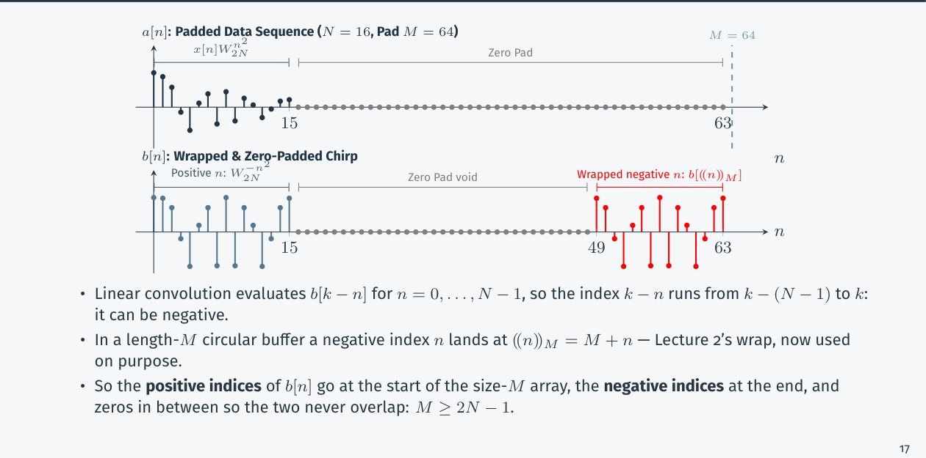
Figure 8.1 — Bluestein padding: positive chirp indices at the start, negative ones wrapped to the end (Lec 4, sl. 21)
Padding: k − n runs from −(N−1) to N−1, so b has 2N − 1 samples. In a circular buffer of length M an index −m
lands at M − m. Put b[0..N−1] at the start, b[−(N−1)..−1] at the end, zeros between. They must not overlap:
M ≥ 2N − 1 (choose M = 2^{⌈log₂(2N−1)⌉} so radix-2 FFTs apply — the prime N never touches the transform length).
Steps: A = FFT_M(a padded), B = FFT_M(b wrapped), y = IFFT_M(AB), X[k] = W_{2N}^{k²}y[k], k = 0…N−1.

Practice — Lesson 8
(a) Actual — CSE 219 2023-24 Q7(b). (b) Practice set 3.2.
(a) Derive the N-point DFT as a linear convolution using the chirp-z identity kn = n²/2 + k²/2 − (k − n)²/2, outline its fast-convolution implementation and explain the padding requirement M ≥ 2N − 1. (10)
(b) Use Bluestein's construction to compute the 3-point DFT of {2, −1, 3}.

✔ Solution
(a) Derivation and padding argument in the two grey boxes above. Implementation: form a[n] (N samples) and the chirp b[n] (2N − 1 samples); pick M ≥ 2N − 1, a power of 2; zero-pad a to M; place b circularly (wrapped negative indices); radix-2 FFT both; multiply; IFFT; multiply the first N outputs by the post-chirp W_{2N}^{k²}. Cost O(M log M) = O(N log N). Why M ≥ 2N − 1: a circular convolution of length M equals the needed linear values only if the wrapped negative-index part of b and its positive part do not overlap (and the wrap does not alias outputs k = 0…N − 1); with M < 2N − 1 some chirp samples land on top of others.
(b) N = 3, W₆ = e^{−jπ/3}: a[n] = x[n]W₆^{n²} = {2, −1·W₆¹, 3·W₆⁴} = {2, −0.5+0.866j, −1.5+2.598j}
b[n] = W₆^{−n²}, n = −2…2; M = 8; result X = {4, 1+3.464j, 1−3.464j} = direct DFT ✓

Quick Notes — FFT
Revision points for Lessons 5–8.

L5 · DIT
- X[k] = G + W^kH, X[k+N/2] = G − W^kH; bit-reversed input.
- Cost: N² vs (N/2)log₂N multiplications; N = 8: 64 vs 12.
- {1,2,3,4,3,2,0,0} → {15, −4.828−5.828j, 1, 0.828+0.172j, −1, …}.

L6 · DIF
- a = x[n] + x[n+N/2] → even k; b = (x[n] − x[n+N/2])W^n → odd k; output bit-reversed.

L7 · Matrix FFT
- n = N₁n₂ + n₁ column-major; rows: N₂-pt DFT; twiddle W_N^{n₁k₂}; columns: N₁-pt DFT; read k = N₂k₁ + k₂.

L8 · Fast conv / Bluestein
- Pad to N ≥ L + M − 1 (power of 2), FFT, multiply, IFFT.
- kn = [n² + k² − (k−n)²]/2 ⇒ X = W_{2N}^{k²}(a * b); M ≥ 2N − 1.

Key Diagrams to Reproduce
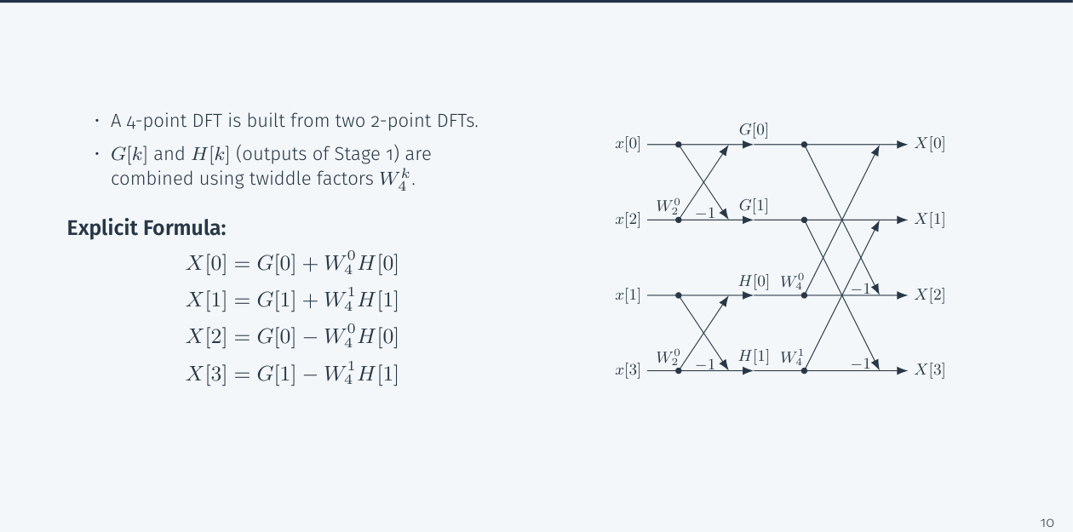
4-point DIT butterfly structure (Lec 3, sl. 11)

